**Introduction**

Software Testing is a method to check whether the actual software product matches expected requirements and to ensure that software product is defect free.

It involves execution of software/system components using manual or automated tools to evaluate one or more  
properties of interest. The purpose of software testing is to identify errors, gaps or missing requirements in contrast to actual

The role of testing in software development begins with improved reliability, quality and performance of the software. It assists a developer to check out

whether the software is performing the right way and to assure that software is not performing what it is not supposed to do.

A test case is a specification of the inputs, execution conditions, testing procedure, and expected results that define a single test to be executed to achieve a particular software testing objective, such as to exercise a particular program path or to verify compliance with a specific requirement

Principle 1: Testing shows the presence of defects, not their absence.  
́Principle 2: Exhaustive testing is impossible.  
́Principle 3: Testing activities should start as early as possible.  
́Principle 4: Defect clustering.  
́Principle 5: The pesticide paradox.  
́Principle 6: Testing is context dependent.  
́Principle 7: No failures means the system is useful is a fallacy

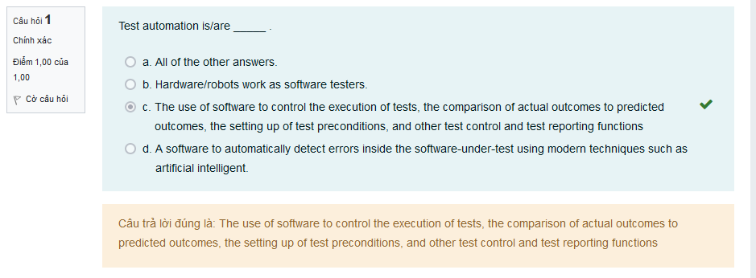

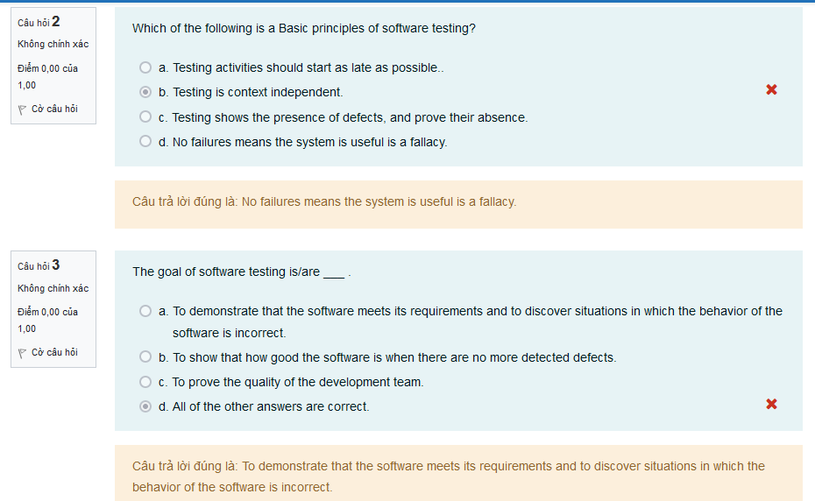

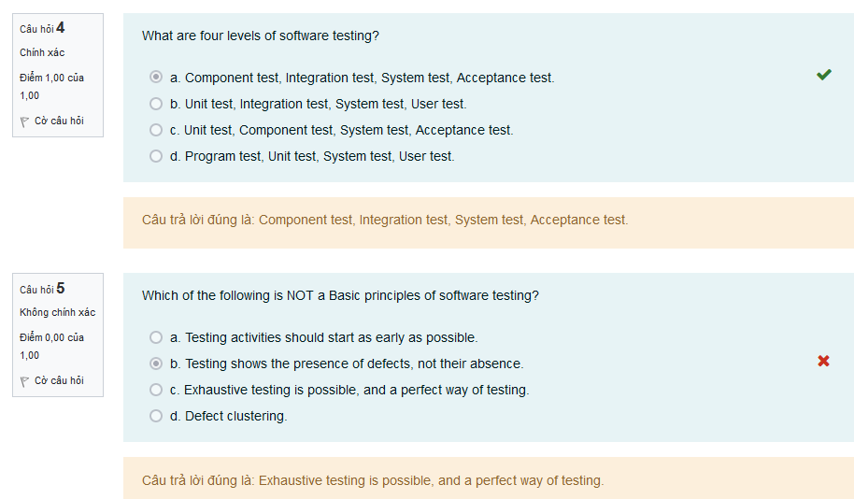

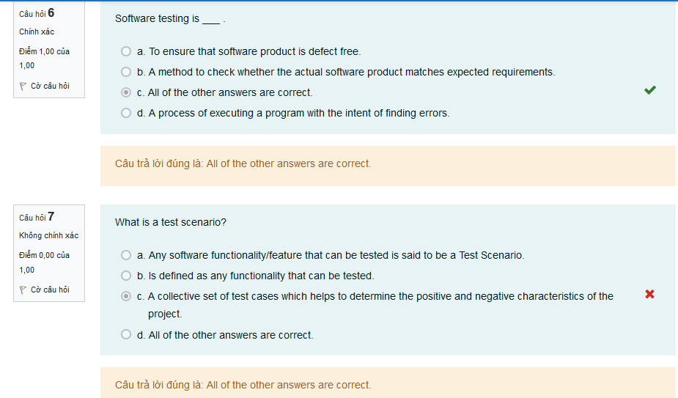

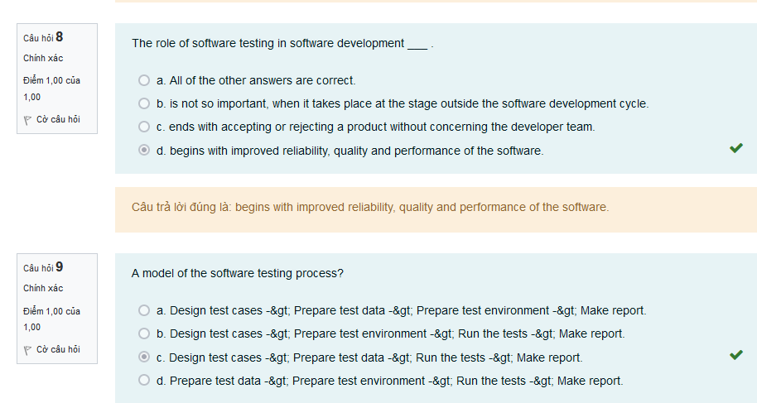

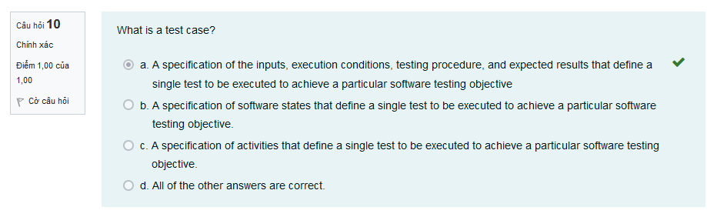

**Software Technical Review**

**White-box Testing**

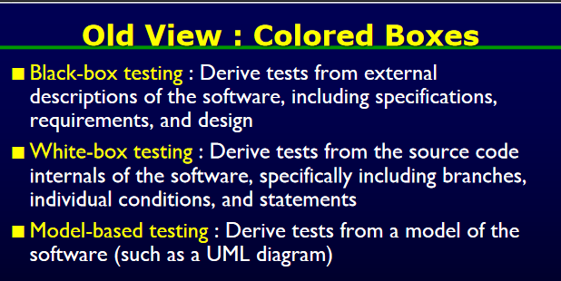

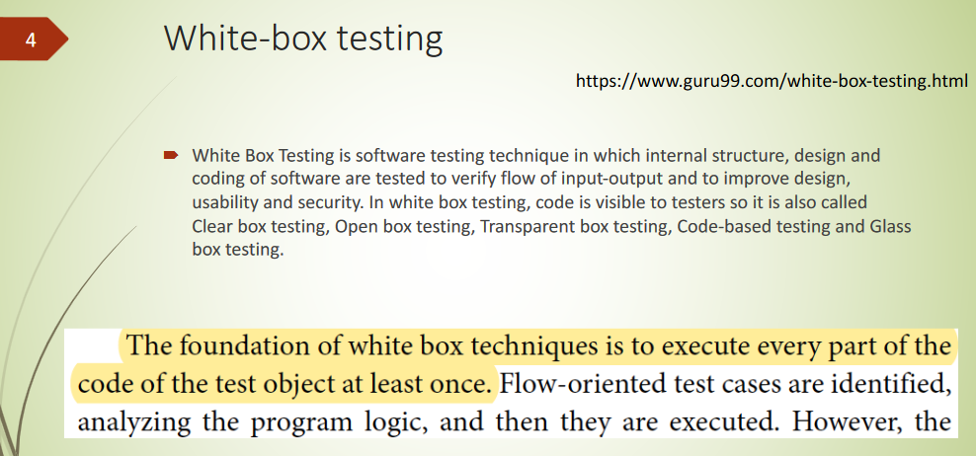

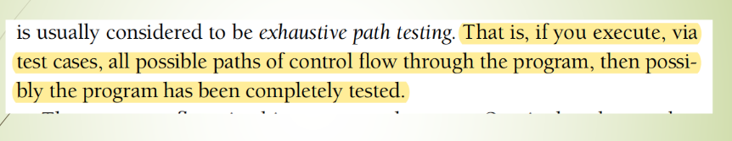

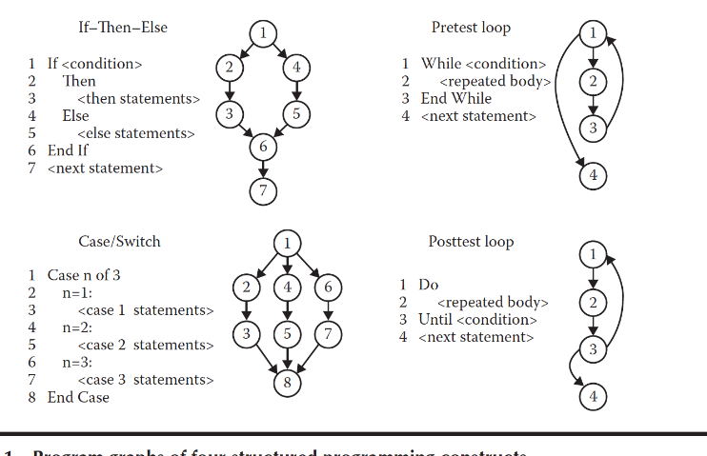CONTROL FLOW

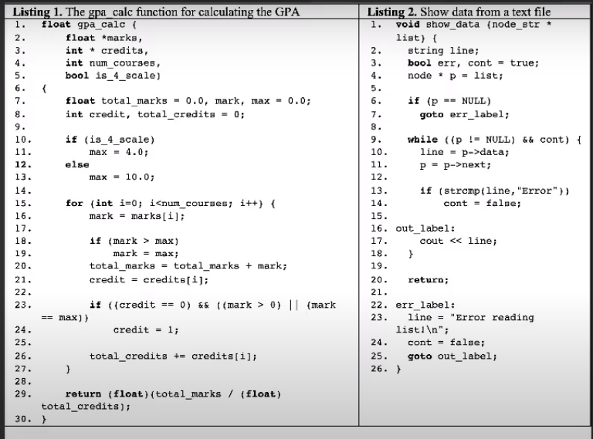

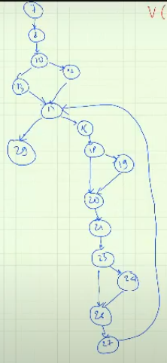

**Path Testing**

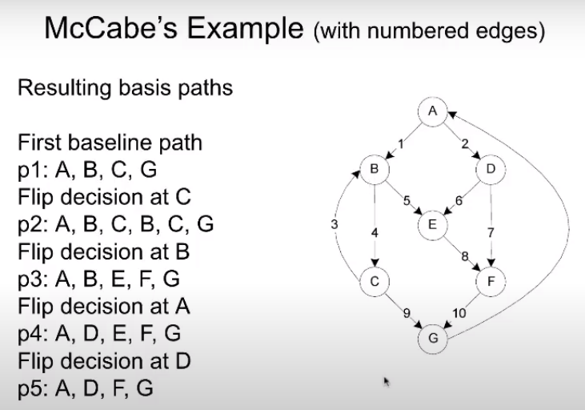



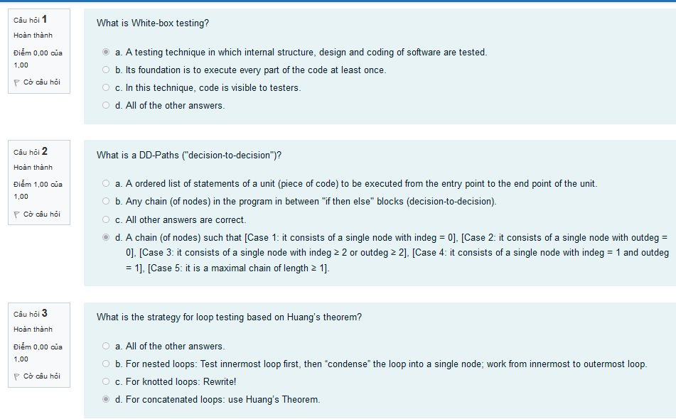

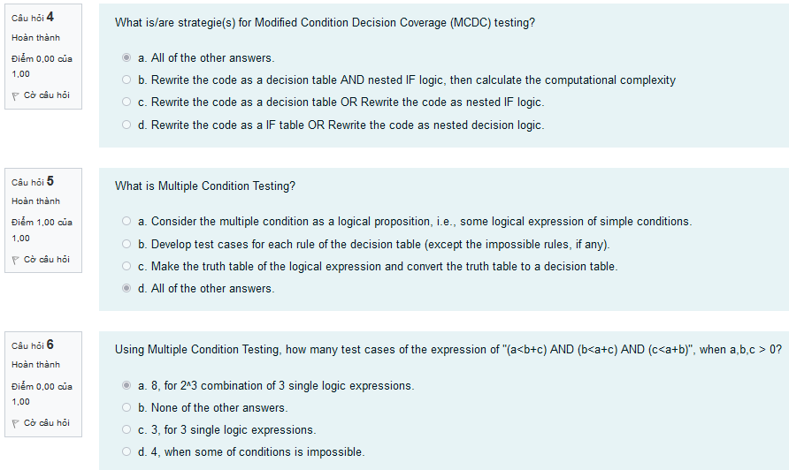

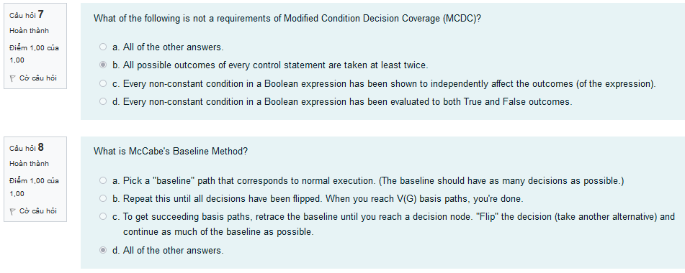

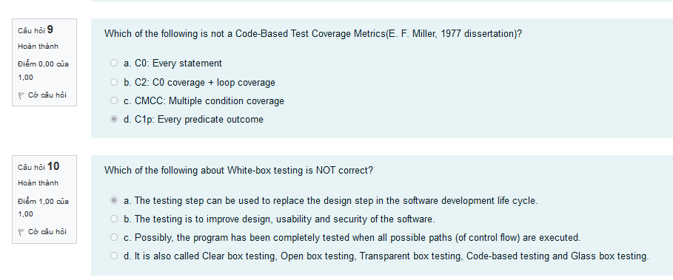

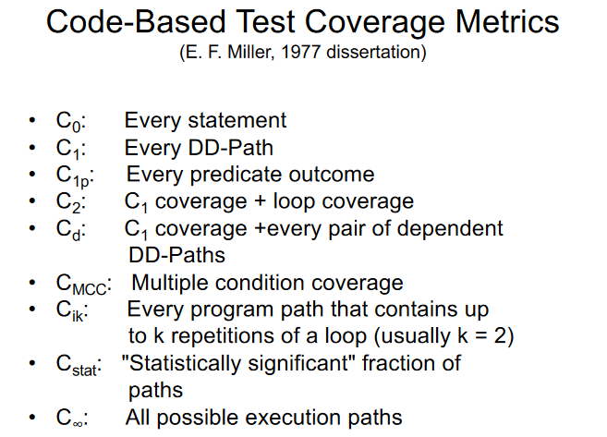



**Dataflow and Slice Testing**

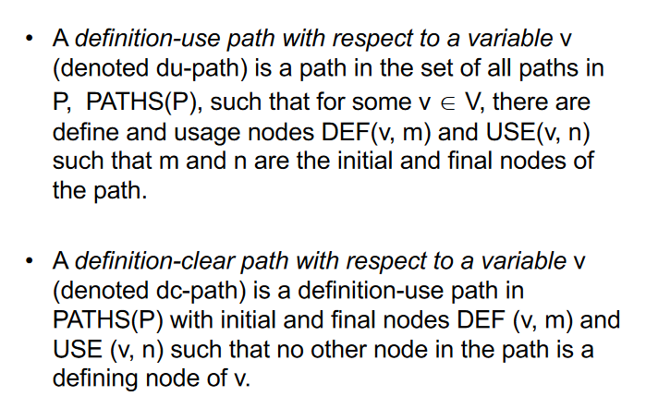

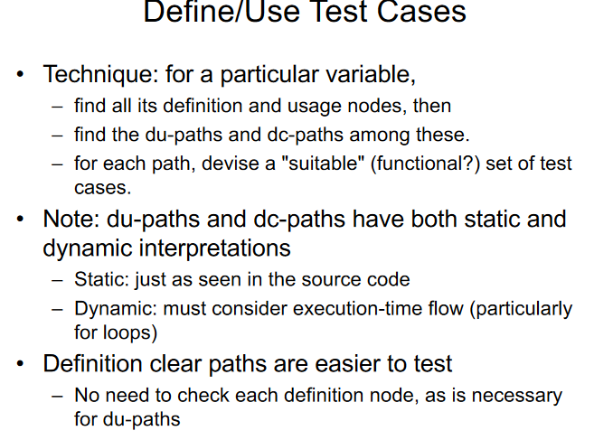

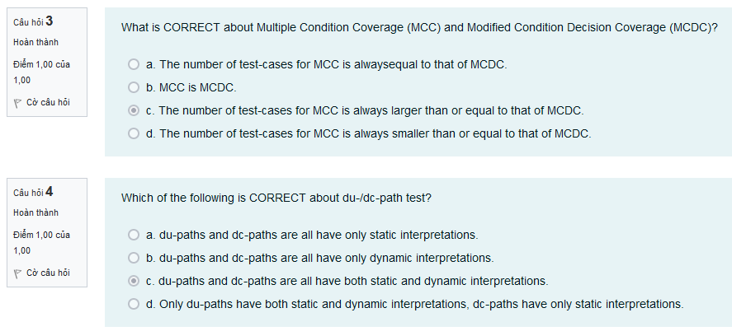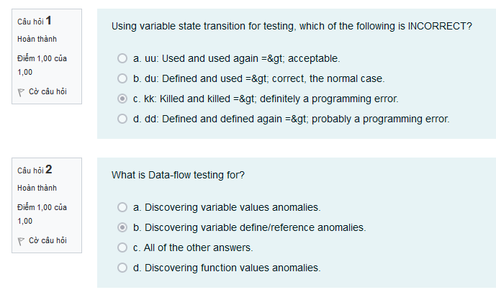

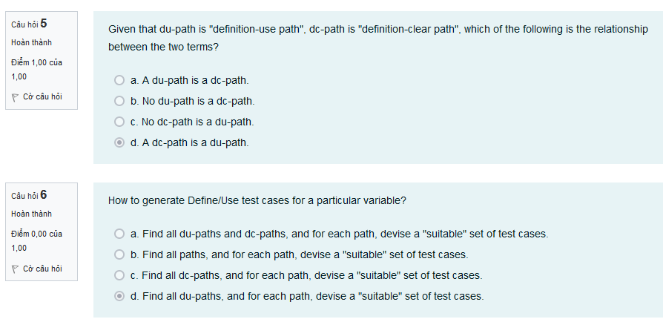

6 sai

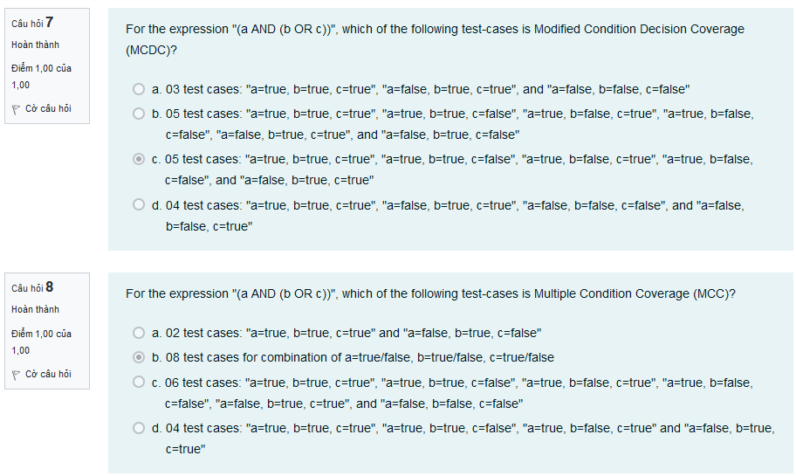

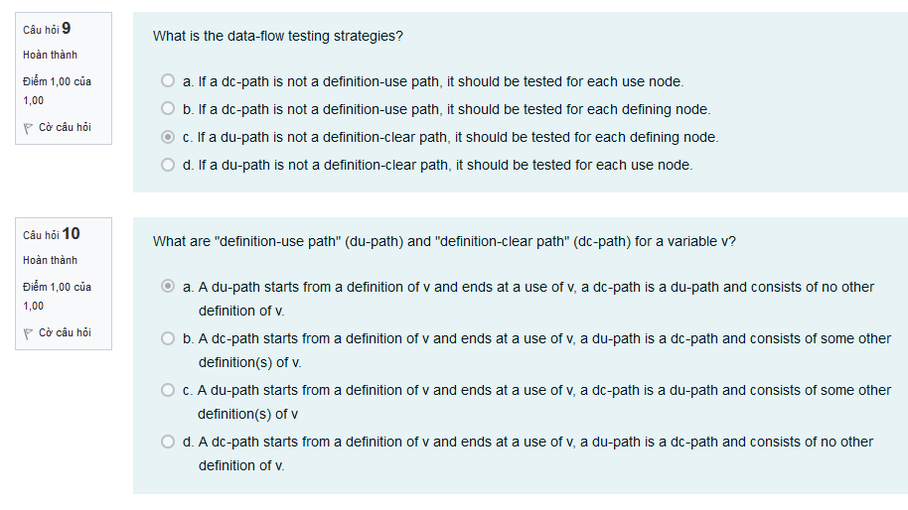

**Blackbox Testing**

